2 DAY RED DOT PISTOL COURSE 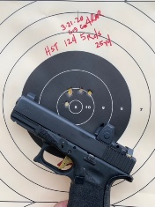

CSAT Staff will instruct a two-day Tactical Red Dot Pistol Course in NACOGDOCHES, TEXAS.

Class Dates:

24-25 April
22-23 May

New or Old Shooters who are looking for a two-day Red Dot Sighted Pistol (RDS) covering the following:

COURSE TOPICS:

Safety Range Fire and Standards
Zero Equipment Overview for your particular needs
How to Dry Fire Maintenance

Tactical Drills include: Movement to include Lateral F & M, Forward F & M, Open Door Room Pies, Closed Door Room Pies, T- Intersection

PHYSICAL REQUIREMENTS:

Adequate Physical Shape

EQUIPMENT NEEDED:
Pistol with RDS, Eyes, Ears, Inclement weather gear. 3 pistol mags and quality holster.

Students need a notebook/pad to take notes. Water. Bring a Thumb Drive of 64 G or larger for class information.

Pistol Ball (or duty) 300

HOTELS: Several local and close (Holiday Inn Express, Hampton Inn, etc.)

BARRACKS AVAILABLE
Barracks can be made available

This course is limited (10 students). Tuition-$600 per student

Contact Paul at: paulkoko@hotmail.com
No refunds/cancellations 30 days prior to class start.

